# 3 : Git-HOL

**Branching:**

### Step 1: Create a New Branch

Command:git branch GitNewBranch

**Step 2: List branches (local & remote):**

Command: git branch -a

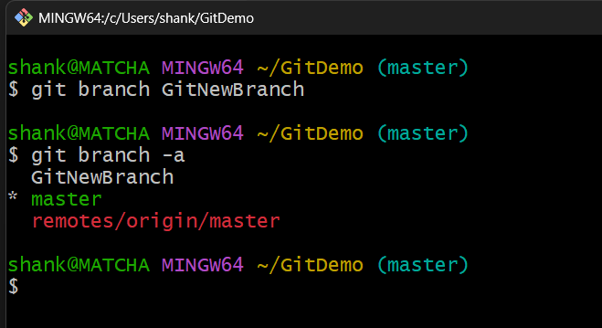

Here * denotes the current thing.

**Step 3: Switching to new Project:**

Command: git checkout GitNewBranch

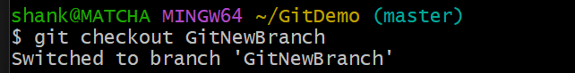

### Step 4: Create a File with commit and Add Content

* echo "Adding some content to file >some.txt

git add some.txt

git commit -m "Added some.txt in GitNewBranch"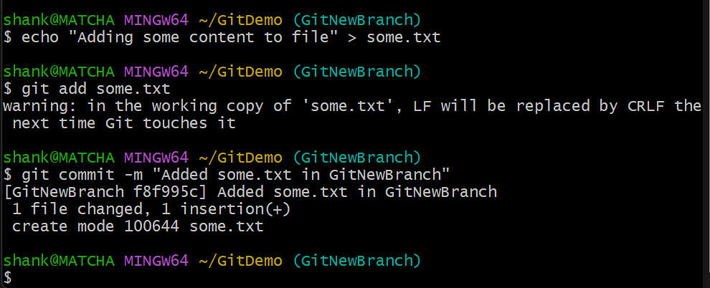

### Step 5: Check Branch and Status

* git status

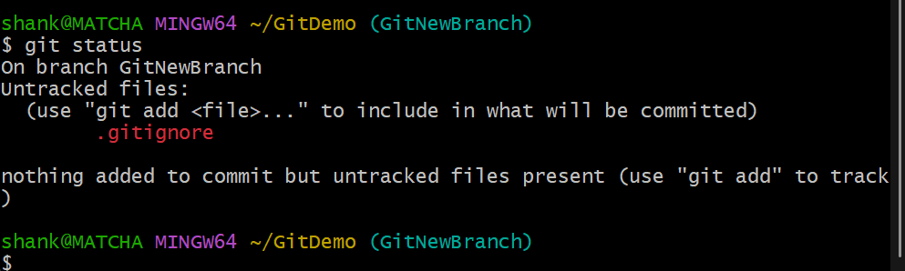

**Merging:**

### Step 1: Switch to Master/Main

* git checkout master

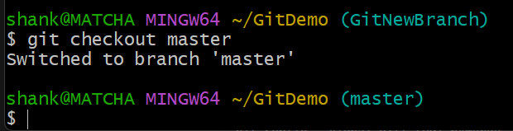

### Step 2: View CLI Differences

* git diff master GitNewBranch

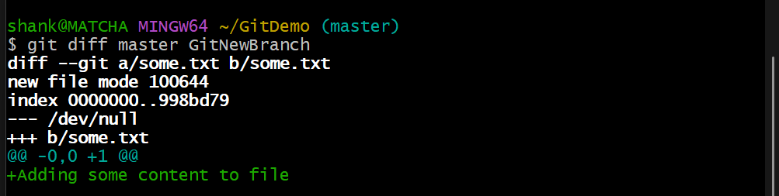

### Step 3: View Visual Differences with P4Merge

* git config --global merge.tool p4merge
* git config --global mergetool.p4merge.cmd "C:/Program Files/Perforce/p4merge.exe" "$BASE" "$LOCAL" "$REMOTE" "$MERGED"
* git difftool master GitNewBranch

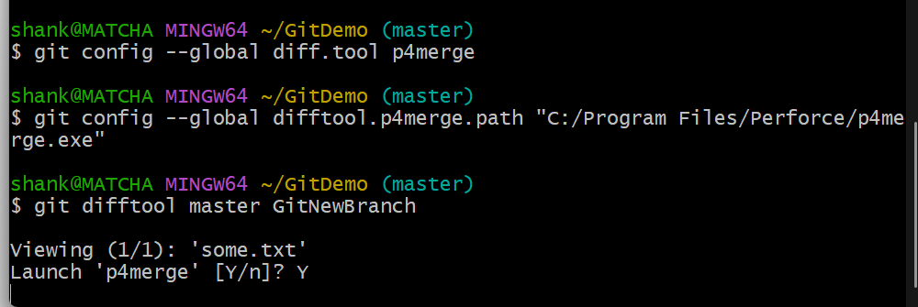

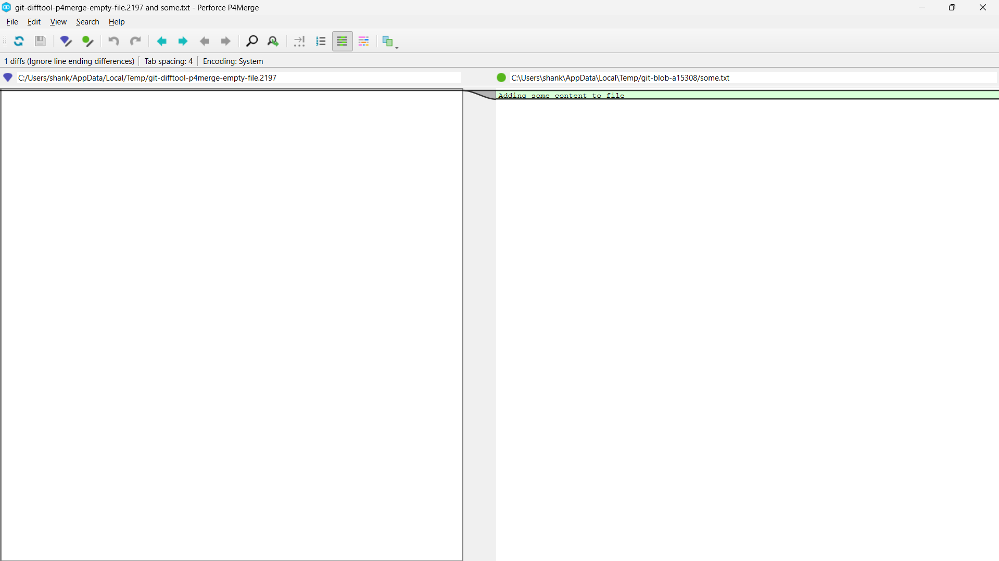

### Step 4: Merge the Branch

* git merge GitNewBranch

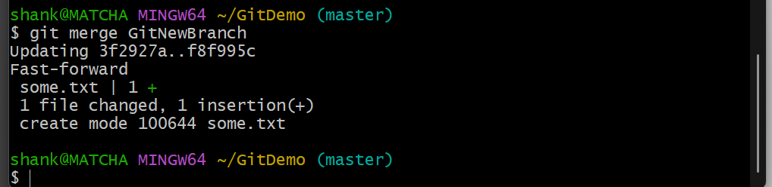

### Step 5: View Logs

* git log --oneline --graph –decorate

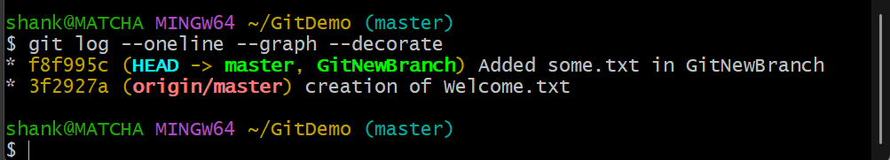

### Step 6: Delete Remote Branch (Optional)

* git push origin --delete GitNewBranch

